

***My Target: ____ /36 or ______ % Complete on the day of the test***

***🖒 🖓 (Circle when your test is handed back)***

**Name: __________________ Teacher: _______________**

**Assessment 8-Part B –** In Class Validation **(2.5%)**

|  |  |
| --- | --- |
| ***Total Mark*** | ***%*** |
| ***/36*** |  |

*Technology in the workplace*

**READING TIME – 5 Minutes**

**WORKING TIME – 40 Minutes**

1. List four jobs that you researched the likelihood of automation in Part A of assessment 8.

(4 marks)

* _________________________________
* _________________________________
* _________________________________
* _________________________________

1. Choose one of the jobs from the list above and discuss how likely it would be for that job to be automated in the next 20 years.

(4 marks)

**Job**_________________________________

_____________________ ______________________________________________________________________

1. Refer to Source 1 to answer the questions below;

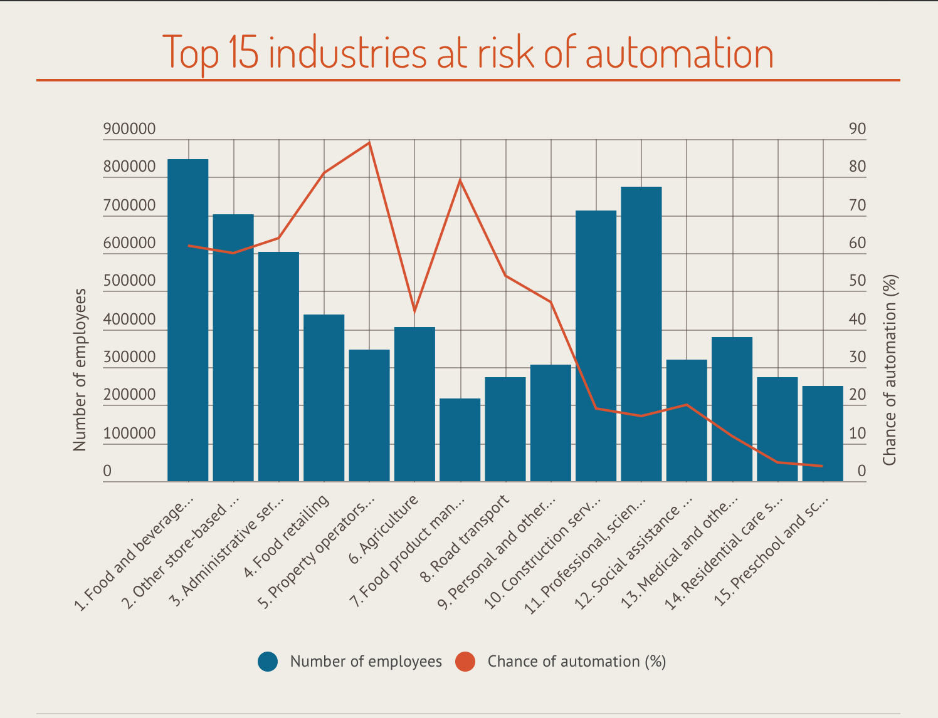

*Source 1: 2018 Australian Job Automation Report by Finder.com.au*

1. State which industry has the highest percentage chance of automation. (1 mark)

__________________________________________________

1. State which industry has the highest number of employees. (1 mark)

__________________________________________________

1. State what percentage chance the agriculture industry has of automation. (1 mark)

__________________________________________________

1. Using evidence to support your response, outline which industry automation will have the greatest impact on.

(3 marks)

1. Refer to Source 2 to answer the questions below;

|  |  |
| --- | --- |
| **State** | **Percentage total of jobs at risk of Automation** |
| South Australia | 41% |
| Northern Territory | 34% |
| Western Australia | 35% |
| Queensland | 35% |
| Victoria | 35% |
| Tasmania | 33% |
| New South Wales | 31% |
| A.C.T | 29% |

*Source 2: A research produced by labour market experts Adzuna in March 2018. The source shows what percentage of total jobs are at risk of automation in each state in Australia.*

1. State which state has the highest percentage total of jobs at risk of automation.

(1 mark)

__________________________________________________

1. List which states have percentage total lower than 35%.

(1 mark)

__________________________________________________

1. Explain why you believe that South Australia has such a high percentage total of jobs at risk of automation. Use examples from your research to support your argument.

(4 marks)

___________________________________________________________________________

1. Display the information from Source 2 in a bar graph using the graph provided. You must remember; (10 marks)

* An appropriate title of the graph
* Appropriate titles for the Y and X axis
* Appropriate scale
* Ensure the data is recorded accurately using a ruler



1. Hypothesise what changes may occur in the Australian workforce in the next 20 years. Use examples from your research to support your hypothesis.

(6 marks)

END OF ASSESSMENT